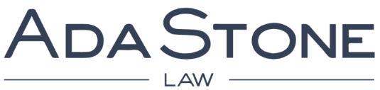

Associate
AdaStone is a European law firm with offices in Brussels and Paris. We are a young, dynamic and ambitious law firm with a varied clientele, both national and international. We mainly focus on the Media & Entertainment, Advertising & Communication, Data & Technologies, Transport & Infrastructure and Insurance sectors.
Due to our expanding business in the Media, Communication and Data departments, we are currently looking for a dynamic associate to join the team.
Your career at AdaStone
AdaStone provides you the opportunity to work in an interesting and challenging environment, with training, personalized assistance and the possibility to develop your career.

Within our Media & Entertainment and Advertising & Communication departments, you will advise leading players in the media and communication ecosystem (Film, TV, Radio, platforms, producers and post-producers, advertising and media agencies, advertisers, …). You will focus on regulatory issues, intellectual property rights and trade practices, including counselling, prosecution, strategic advice, litigation, drafting and negotiation of agreements and IP-portfolio management. You will also assist clients in their projects related to privacy regulation (GDPR implementation, data protection policies, …) and will be involved in providing in-house trainings and seminars.

Our team members are all recognised lawyers in their field and you will be able to benefit from their experience and knowledge. We also offer a very attractive remuneration package.

Your profile
- You have an open personality and are a good communicator;
- you are a good team player;
- you are pragmatic, dedicated, proactive and willing to achieve;
- you have 2-5 years of relevant experience;
- you have excellent language skills, being at least bilingual Dutch & English or Dutch & French;
- you have an entrepreneurial spirit and are interested in supporting business development activities to further grow the practice.

We offer
- opportunities to contribute to the development of a fast-growing practice;
- interesting and challenging work for an international clientele;
- time and resources for your professional development and career planning;
- feedback, follow-up and partner assistance on personal projects; and
- upscale compensation and benefits.

Interested candidates are invited to send their cover letter and resume to career@adastone.law
All applications are treated with strict confidentiality.

